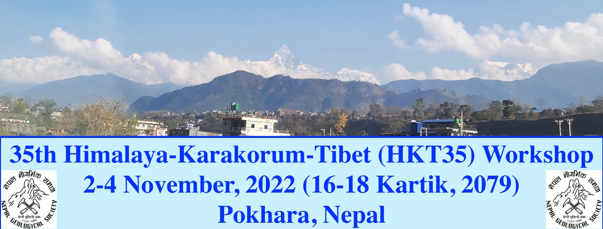

**Dear HKT community,**

Greetings from Kathmandu, Nepal!

We would like to remind you that we are going to organize the 35th Himalaya-Karakorum-Tibet workshop in Pokhara, Nepal from November 2 to 4, 2022. Pokhara is the Headquarters of Gandaki Province, which is one of the most beautiful cities in Nepal with the fantastic view of Annapurna range to the north. We apologize for delaying and rescheduling to this new date of the conference because of the COVID-19 pandemic. We are very optimistic about the normal world from the rare effect of the COVID-19 pandemic up to November, 2022.

We request your active participation in the international conference (HKT-35) at Pokhara, Nepal, related to the Himalaya, Karakorum, and Tibet. The conference sessions will be prepared based on the received abstracts. Please, send your abstract to communicate at the conference your new recent findings related to the following

**THEME**

1. Geomorphology, geological mapping, stratigraphy, and regional tectonics

2. Advances in Mineralogy, Petrology, Geochemistry, Geochronology, and Thermochronology

3. Mineral Exploration, Mineral Resources and Mining, Petroleum, and Natural Gases

4. Engineering Geology, Tunneling, and Hydropower Development

5. Geo-Hazard Assessment, Risk Reduction, and Mitigation for Sustainable Infrastructure Development

6. Environmental Geology, Hydrogeology, and Water Resources

7. Advances in Geophysics, Seismology, and Seismo-tectonics

8. Glaciology, Environment, Climate Change and Adaptation

9. Plans, Policies, and Strategies of the Nepal Government for the Application of Geosciences in Sustainable Infrastructure Development

10. Geosciences and gender history

11. Geo-tourism and Geo-heritage Conservation.

12. Promoting Geoethics for Sustainable Development

13. Recent Developments in Geoscience Software, Laboratory Facilities, and Findings

14. Recent Trends and Advances in Geosciences

**ABSTRACT SUBMISSION:**

Please, check the abstract submission template on the website of the Nepal Geological Society at <https://ngs.org.np> or for further inquiry, please write to the Convener, Dr. Kabi Raj Paudyal at [paudyalkabi1976@gmail.com](mailto:paudyalkabi1976@gmail.com) or to the Chief-Editor, Dr. Prem Bahadur Thapa at [geoscithapa@yahoo.com](mailto:geoscithapa@yahoo.com) and to the President, Dr. Ananta Prasad Gajurel at [35hkt.nepal@gmail.com](mailto:35hkt.nepal@gmail.com).

The abstract submission deadline is July 31, 2022. Abstracts are invited for both oral and poster presentations in English. All the abstracts received for oral and poster presentations in the conference will be printed in a special volume of the Journal of the Nepal Geological Society and distributed to the registered participants. Full articles related to oral and poster presentations will be published in a special issue of the Journal of the Nepal Geological Society.

**REGISTRATION AND PAYMENTS**

Because of the COVID-19 pandemic and the world's present scenario, we are calculating the registration costs and payment for the HKT-35 workshop for November 2-4, 2022. We will update you all the information related to the registration cost and other geological field trip events very soon.

Similarly, we will recommend you all for your preferred accommodation in the numerous hotels located within the city of Pokhara. A list of recommended hotels will be published on the website of the Nepal Geological Society.

We request you all to please communicate the information to your colleagues for their active participation in the coming HKT-35 workshop in Pokhara, Nepal.

We look forward to welcoming you all to Pokhara!

**CONTACTS:**

**Dr. Lok Bijaya Adhikari – General Secretary**

* Department of Mines and Geology, Lainchour Kathmandu
* Tel: 9858050888
* Email:lbadhikari@hotmail.com

**Dr. Ananta Prasad Gajurel – President**

* Department of Geology,
* Tri-Chandra Campus, Tribhuvan University, Ghanta Ghar, Kathmandu
* Tel: 9841888116
* Email: apgajurel@fulbrightmail.org

18th May 2022

With best regards,

Ananta Prasad GAJUREL, President

*(Provisionally edited by M. Yoshida, June 18th, 2022)*

Nepal Geological Society