Chapter’s Report on the GIGE Activity in 2024

Related Activities of the GIGE Tokyo Office during the 2024 fiscal year (January-December 2024) are given below. Several reports for both scientific conferences and business meetings are included involving Antarctica, South Africa and other Gondwana continental areas.

1. SCAR Open Science Conference & Business Meeting Report
- XI Scientific Committee on Antarctic Research (SCAR) - Open Science Conference and related business meetings were held at Pucon, Chile, 19-23 August 2024. The Chapter (Masaki Kanao) attended the conference and participated in his involved sessions and meetings. Regarding the scientific data, he attended the SCADM (Standing Committee on Antarctic Data Management) as a committee member, made presentations at a FAIR data session and a workshop on Data Management Resources, respectively. On the other hand, the 5th IPY (International Polar Year 2032-2033) has launched, and some preliminary information was demonstrated. An International Sterring Committee and four Task Groups were proposed and started their activities.
- Geoscience related sessions and meetings were also conducted and the Chapter participated. SCAR GSG (Geosciences Science Group) committee approved a new action group (Groundwater) and a new scientific research programme (Antarctic Geological Evolution; AGE). There will be an International Symposium on Antarctic Earth Sciences (ISAES) at Punta Arenas, Chile, in mid-August 2025. Business meetings were also held; Antarctic Seismic Data Library System for Cooperative Research (SDLS), Climate and Cryosphere (CliC), Polar Research Infrastructure Network (POLARIN), BEDMAP-3 (a project for compiling the data on topography of the bedrock within the Antarctic continent), Expert Group on Geological Heritage and Geoconservation (EG-GEOCON), respectively. The Chapter attended all these meetings and exchanged discussions for promoting their activities.

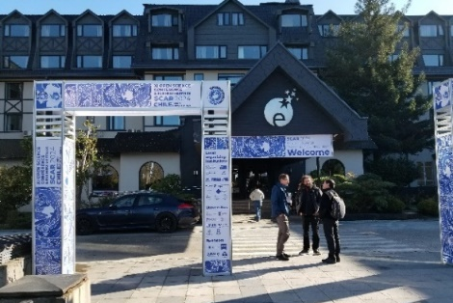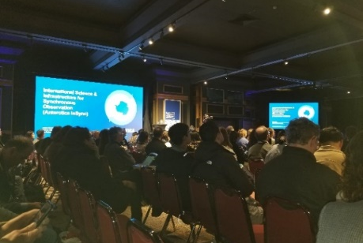

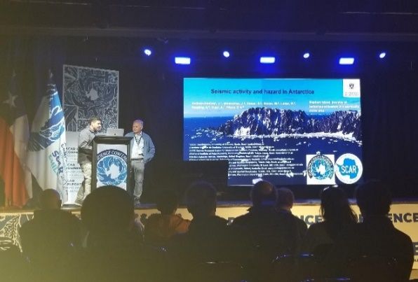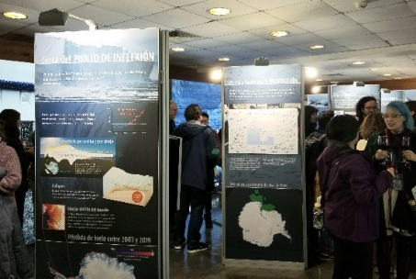

Conference place (Hotel Enjoy Pucon) for the SCAR meetings (upper left panel), opening session of SCAR-OSC (upper right panel), geoscience science group meeting (lower left panel) poster room at coffee break (lower right panel), Pucon, Chile, 19-23 August 2024.

２．International Project to Study the Archaean Craton in South Africa
- SEISMIX 2024; The 20th International Symposium on Deep Seismic Profiling of the Continents and their Margins (SEISMIX 2024) was held at Uppsala, Sweden, 24-28 June, 2024. Characteristics of the seismogenic zone of the 2014 Orkney M5.5 earthquake, in the Kaapvaal Archaean craton of South Africa was presented by one of the Co-Workers of Chapter. This seismogenic zone was located below Moab Khotsong mine, in the Witwatersland basin within the Kaapvaal craton. Several tens of in-mine seismic stations installed at 2-3 km depth elucidated the upper fringe of the aftershock zone. It proved to be within drillable range from the deepest level from the mine, and the International Continental Scientific Drilling Program (ICDP) approved the project "Drilling into seismogenic zones of M2.0-5.5 earthquakes in South African gold mines (DSeis)" in 2016 (lead by Prof. Ogasawara, Ritsumeikan University).
- DSeis-PROTEA meetings were held at the Ritsumeikan Tokyo Campus on 3 June, and at the National Institute of Polar Research (NIPR), Tokyo on 3 December 2024, respectively. The proposed follow-up PROTEA project (Probing the heart of an earthquake and life in the deep subsurface; lead by Prof. Yabe, Tohoku University) that aims to investigate the strong-motion sources of the 2014 Orkney earthquake with additional drilling, combined with high-resolution seismic imaging using active and passive seismic energy sources and distributed acoustic sensing (DAS) and seismic node sensors. The pre-proposal was submitted to ICDP in January 2024 and an international workshop will be planned during 2025 physical year.
- Both the above conferences, for a comparison with those in South Africa, characteristic seismic structure of the crust and lithospheric mantle of the Pan-African mobile belt, the Lützow-Holm Complex (LHC), East Antarctica was presented by the Chapter as a review talk of the activities in the Japanese Antarctic Research Expeditions. A plan is proposed to conduct a shallow seismic reflection survey in the LHC by using portable active sources to investigate the geological boundary of the area. It is important to fill the gap between the surface geological information and the crustal structure down to a few km in depth to reveal the tectonic history of the area.
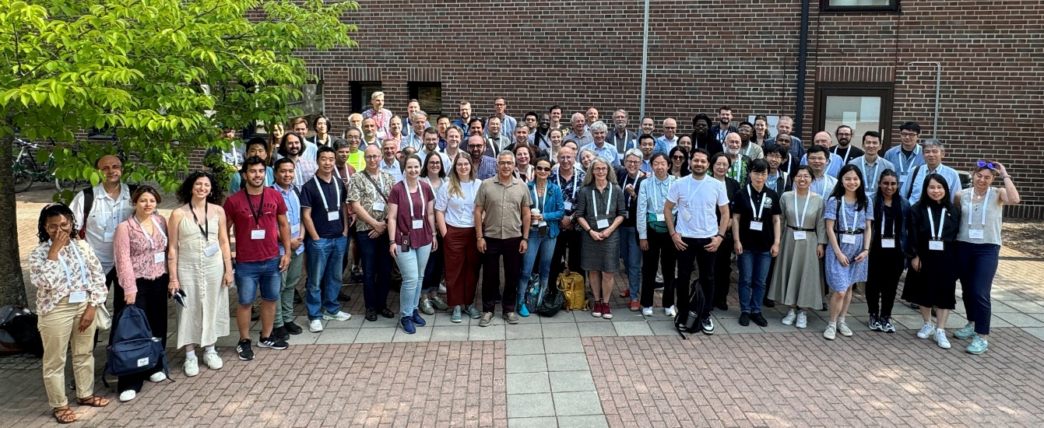

Group photo of all participants in the SEISMIX 2024 conference, Uppsala, Sweden, 24-28 June, 2024.

Other Activities
- The 15th NIPR Symposium on Polar Science was held at NIPR, Tokyo, Japan from 3 to 5 December 2024. A total of 28 presentations for geology and geophysics in Gondwana areas were made at the Geoscience Session [OG].
- At the symposium, Polar Data Science session [ID] was also held, for which was served by the Chapter as a lead-convener. A total of 20 presentations for data science approach to all kind of geoscientific data were presented including the regions from South Africa and India.
- Director of the International Seismological Centre (ISC), Dr. Dmitry A. Storchak was invited to serve as the International Strategy Advisor for the Research Organization of Information and Systems (ROIS) for one month (Nov.-Dec.), and during his stay in NIPR he provided advice on the operation of ROIS, as well as the release of data archives. He also gave presentations at the NIPR Special Seminar and the 15th Polar Science Symposium.

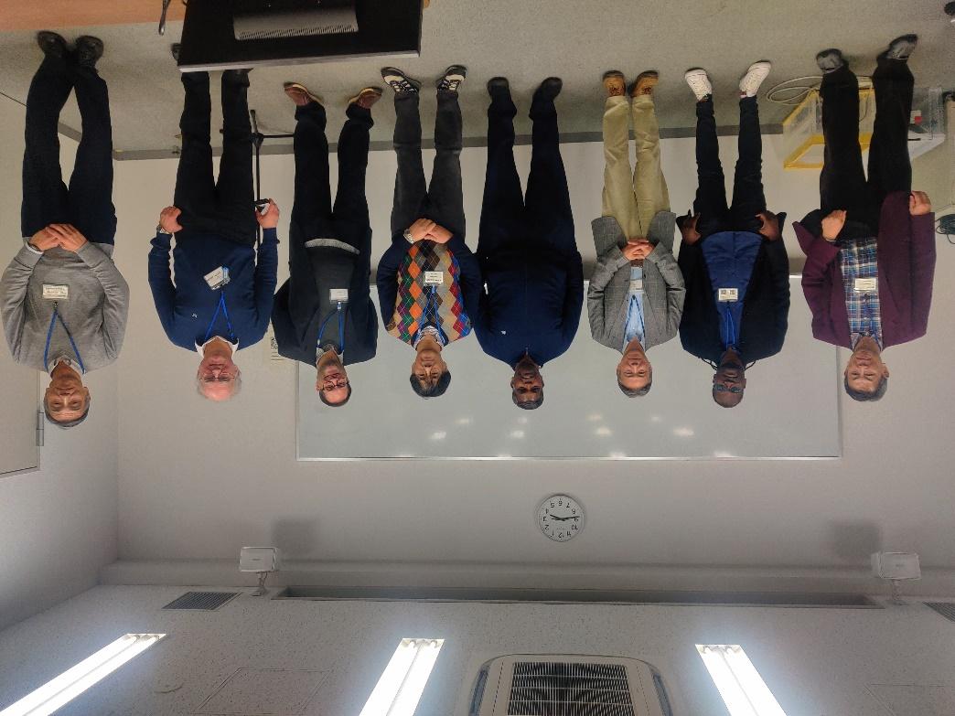

Group photo of related oversea participants (South Africa, India, UK (ISC Director) and DataCite) in the NIPR annual symposium, Tachikawa, Tokyo, 3-5 December 2024.

Publication of Papers and Presentations by the Chapter and Co-workers
- Kaoru Fujita, Hiroshi Ogasawara, Masaki Kanao, Ryogo Tadokoro, Shigeki Horiuchi, Makoto Okubo, Makoto Naoi, Musa Manzi, Koichiro Suzuki, Kotaro Ogawa and DSeis team, Relocation of hypocenters justa round the ICDP DSeis boreholes using the cross-correlation and the Double Difference, JpGU Meeting 2024, S-SS07-10, Makuhari Messe, Chiba, Japan, 26-31 May, 2024
- Kaoru Fujita, DD relocated aftershocks of 2014 Orkney M5.5 earthquake and Vp spatial variation, DSeis-PROTEA Ritsumeikan Tokyo meeting, Ritsumeikan Tokyo Campus, Tokyo, Japan, 3 June, 2024
- Masaki Kanao, Seismic imaging of the crust & lithospheric mantle of the Pan-African mobile belt, the Lützow-Holm Complex, East Antarctica, DSeis-PROTEA Ritsumeikan Tokyo meeting, Ritsumeikan Tokyo Campus, Tokyo, Japan, 3 June, 2024
- Masaki Kanao, Y. Hiramatsu and T. Murayama, Origins of seismic harmonic tremors and associated infrasound in relation to cryosphere hazards in the Lützow-Holm Bay, East Antarctica, SEISMIX 2024, Uppsala, Sweden, 24-28 June, 2024
- Kaoru Fujita, Hiroshi Ogasawara, Yasuo Yabe, Ryogo Tadokoro, Koichiro Suzuki, Shigeki Horiuchi, Makoto Naoi, Musa Manzi, Ray Durrheim, Bennie Liebenberg, van Heerden Esterhuizen, Masaki Kanao and the DSeis team, The seismogenic zone of the 2014 Orkney M5.5 earthquake, South Africa, SEISMIX 2024, Uppsala, Sweden, 24-28 June, 2024
- Almendros, J., S. Cesca, J. Galindo-Zaldivar, M. Kanao, R. Larter, A. Reading, A. Vuan, D. A. Wiens, Seismic activity and hazard in Antarctica, XI SCAR Open Science Conference 2024, Session No. 10: Antarctica’s evolution through supercontinent cycles to south pole sojourn, Pucon, Chile, 19-23 August, 2024
- Anya Reading, Tobias Staal, Kate Selway, Maria Constanza Manaserro, Matt King, Jack Beardsley, Shyla Kupis, Niam Askey-Doran, Lenneke Jong , Andrew Kleckocuik, Joel Pedro, Felicity McCormack, Sarah Thompson, Nerilie Abram, Vincent Favier, Marine Poizat, Guilhem Barruol, Marek Lewandowski, Anastassiya Suhanova, Talalay Pavel, Padma Rao, Vikram Goel, Lei Fu, Masaki Kanao, Tanja Fromm, Mirko Scheinert, Instrumentation for on-ground East Antarctic investigations using geophysical and interdisciplinary approaches: let’s coordinate and build shared datasets!, XI SCAR Open Science Conference 2024, Session No. 47 – Advancing Antarctic Observations for a Sustainable Future: Coordinated Efforts and Global Impacts, Pucon, Chile, 19-23 August, 2024
- Kaoru Fujita, Relocation of hypocenters for the aftershocks of the 2014 Orkney M5.5 earthquake, South Africa, recorded from an underground mine tunnel, PROTEA hybrid meeting, 3 December, National Institute of Polar Research, Tachikawa, Tokyo, Japan, 2024
- Kaoru Fujita, Hiroshi Ogasawara, Yasuo Yabe, Yuhji Yamamoto, Masaki Kanao and Junichi Okuno, Spatial variation in seismic velocity for the dykes recovered in deep seismogenic zone, the Kaapvaal craton in South Africa, The 15th Symposium on Polar Science, OG-o13, 3-5 December, National Institute of Polar Research, Tachikawa, Tokyo, Japan, 2024
- Masaki Kanao, Shigeru Toda and Masahiro Ishikawa, Seismic imaging of the crust and lithospheric mantle of the Pan-African mobile belt, the Lützow-Holm Complex, East Antarctica, The 15th Symposium on Polar Science, OG-o10, 3-5 December, National Institute of Polar Research, Tachikawa, Tokyo, Japan, 2024

December 25, 2024
Dr. Masaki Kanao
Chapter of Tokyo Office, Gondwana Institute for Geology and Environment (GIGE) http://www.gondwanainst.org/
Associate Professor, National Institute of Polar Research
10-3, Midori-cho, Tachikawa-shi, Tokyo 190-8518, Japan
E-mail; kanao@nipr.ac.jp
Tel; 042-512-9026

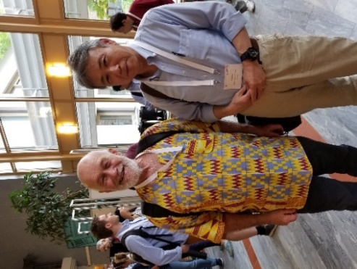

Masaki kanao (Chapter, right) and Ray Durrheim (Professor of Witwatersland University, South Africa; left) at the SEISMIX 2024 conference.

